## 20. Prototypel inheritance and function constructors.

Inheritance - That's when one object, one collection of name value pairs, gets access to the properties and methods, that is, other name value pairs, of another object. So an object has properties and methods, values and functions attached to it. And your object gets access to the properties and methods of that other object. It inherits those other properties and methods.

**However, the way JavaScript implements the idea of inheritance is a bit different than other programming languages But also very powerful because of its simplicity.**

**It implements what's called prototypal inheritance.**

every object has a property that actually points to another object. It's the object's prototype.It's the thing it inherits from. It's the thing it inherits from.

It's a different object that it will then have access to that other object's properties and methods.And so, we could actually say obj.prop2. Whatever that other property is on the prototype, and we'll get access to it as if it was directly attached to my object. And the prototype also might point to a prototype. Its own prototype, a different object which might have its own properties and methods, and we can still take my my object and say dot whatever property name, and we'll still have access to it.

So it's not just what's directly connected to my object, but down what's called the prototype chain.

I have a sequence of objects connected to each other. And I can access properties on any of those objects down the line without having to specify which one it is.

This is prototypal inheritance.

And interestingly, I could make another object. A separate object. And it could point to the same prototype as other objects do. So they can share properties and methods. And I could change the property or method, or add a new property or method to the prototype. And in every object that inherits from it, every object that points to it as its prototype will instantly get access to it.

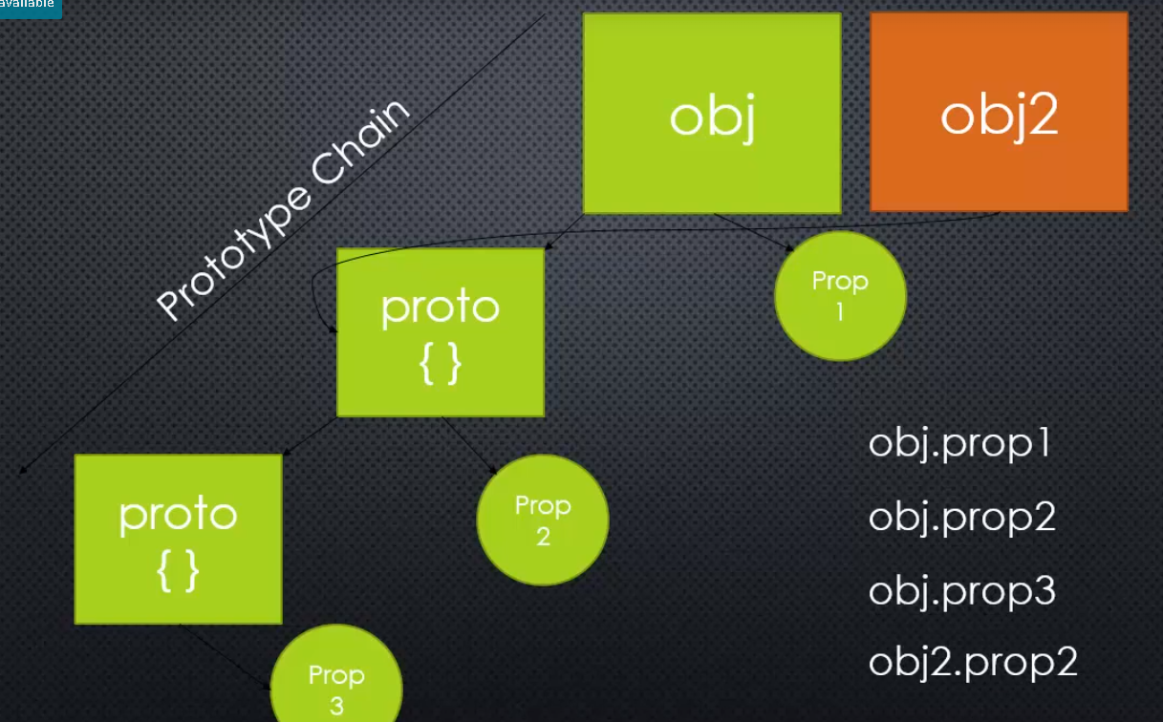

Now the question is, how do we manage building this prototype chain and constructing our objects?

We've already seen the object literal syntax for creating objects. But there are a few ways to create objects in JavaScript that allow us to manage what the prototype is. What object will be the prototype of the object that I'm creating so I can get access to its properties and methods.

There's the new ES6 class keyword. This idea of creating objects based on what's called a class.

When we're talking about Node.js, we're going to be looking at something called **function constructors.**

This is another way to create objects and manage what the prototypes are.

### **Function Constructors –**

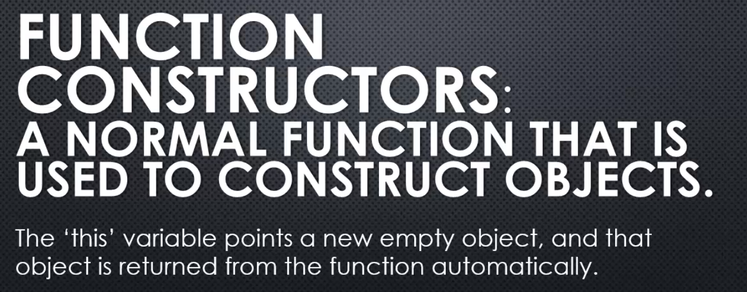

A normal function that is used to construct objects. So we build a function.

However the "this" keyword, that shows up in JavaScript all the time. Will actually point automatically to a new empty object. And then we can add properties and methods

to that new empty object.

That object is returned from the function automatically. And we do this by using the "new" keyword.

So I can say new and then call the function, and what that will do is execute the function. It will take the this keyword, make that a new empty object. We can then use the this keyword to construct our object, adding properties and methods to it.

and then the function constructor will automatically return that new object from that function call.

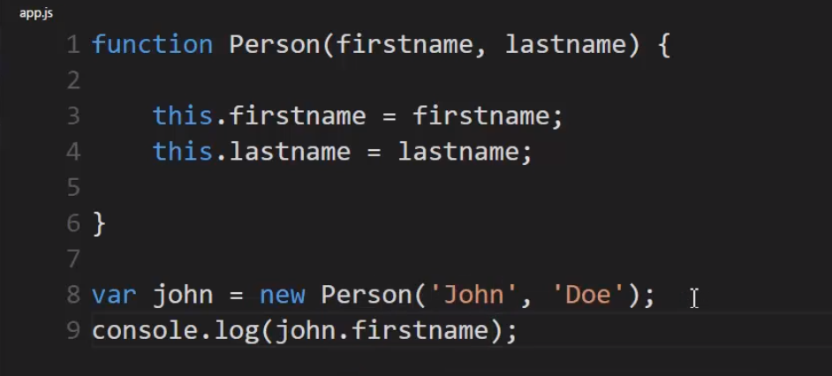

we'll create a function constructor.

Now a function constructor is just a regular function.

I'll use a capital letter to remind myself

that it's a constructor.

But when this function constructor is called

with the new keyword, the this variable

will automatically be an empty object,

and then I can attach things to it.

So I might pass into my function constructor

some values that I want my object to have.

And what about the prototype?The thing that this new object I created, john can inherit from. Well, JavaScript provides a way to do this. It's a little confusing but, Person.prototype. Remember that functions are special kinds of objects. So I can have properties and methods in functions as well. And there's a built-in one called prototype.

That's just an object. Just another object. But I can attach properties and methods to this prototype object as well. So I have a greet function on the prototype.

What happens when you use a function constructor is that any object created from the function constructor, its prototype will point to the prototype property of the function that you used to construct the object. So it's a little confusing because the name is prototype. But this isn't the prototype of Person.It's the prototype of any objects created from Person.

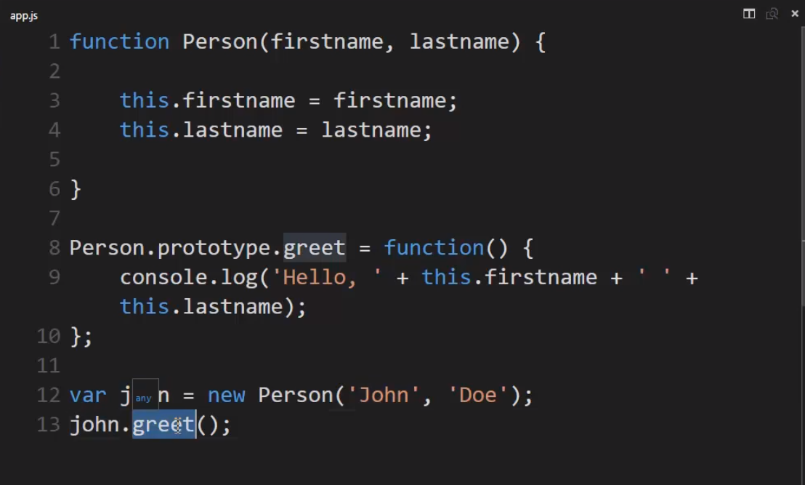

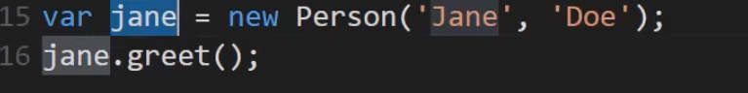

So I can now say john.greet. And the JavaScript engine will search down the prototype chain because there is no greet method on john itself, but there is on its prototype.

And then call it.

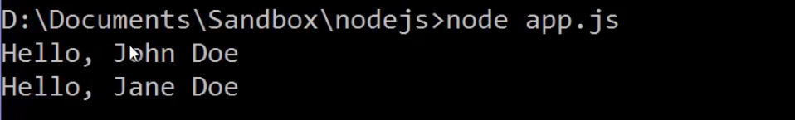

We can actually look at what the prototype is.This is not recommended to use or do in any real production code, but just to show it, there's a special dot underscore underscore proto underscore underscore in the V8 JavaScript engine.That lets me see what the actual prototype object is of an object that I'm working with.

And this proto property for these two objects should be the exact same object because they were both created from the same function constructor.

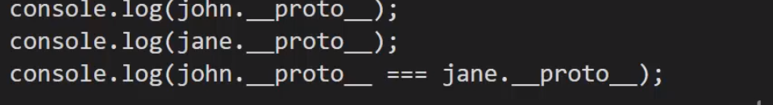

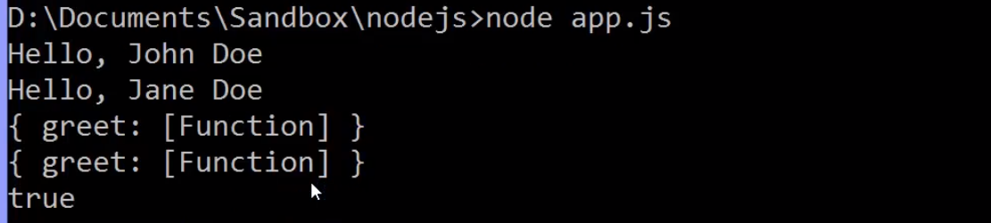

## 21. By Reference and By Value

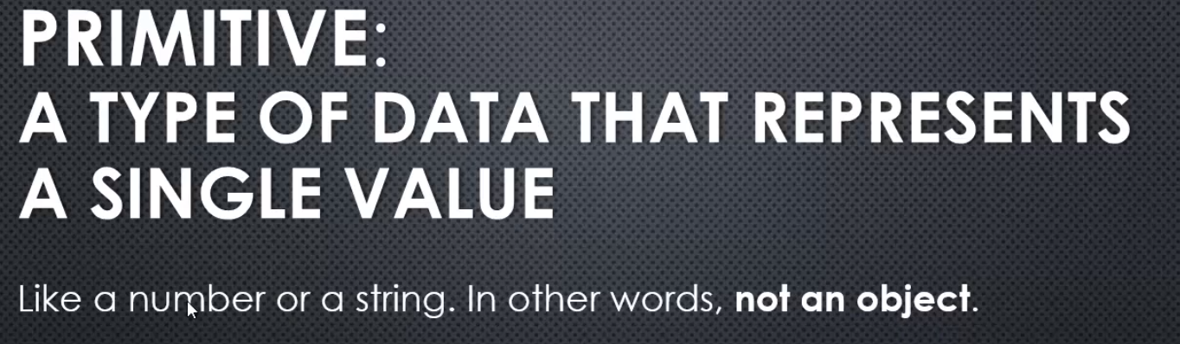

### By Value

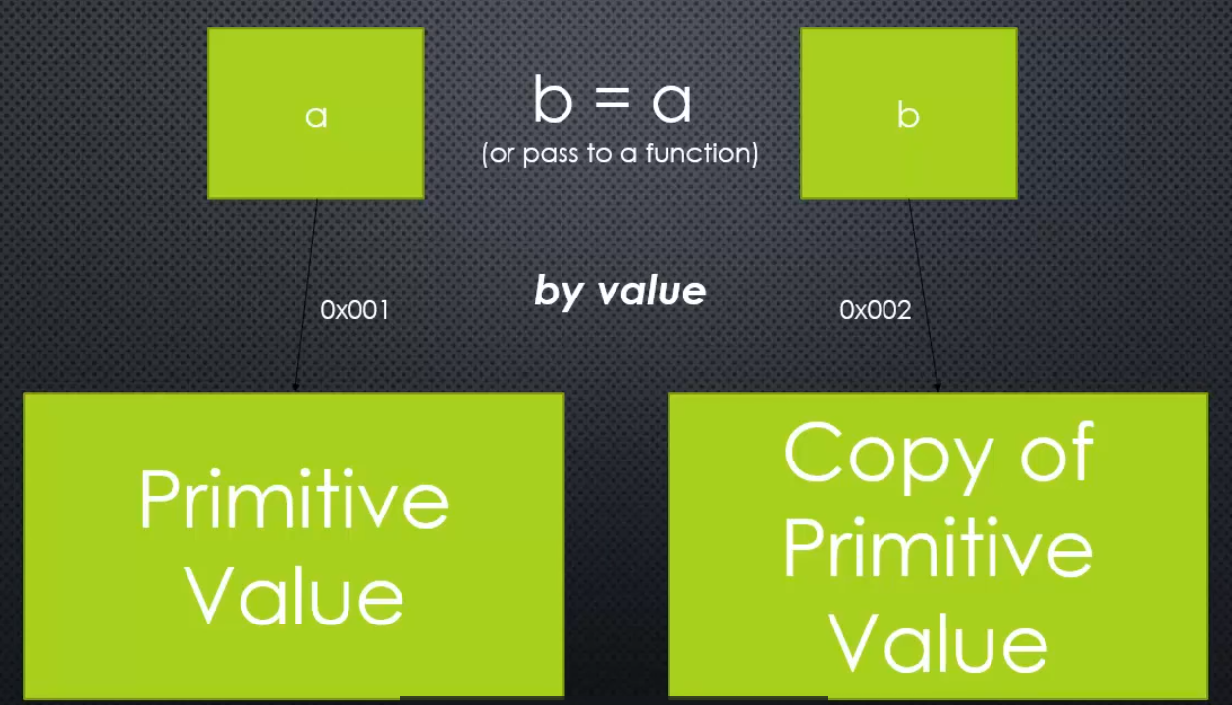

we're talking about passing a value to a function. So just using a function like you normally would, giving it a perimeter. So let's say I have a Primitive value, like a number or a string. And I have a variable, let's call it A. A is actually pointing to a location in memory on your computer, at a particular memory address we call it, and that value, the actual value itself is sitting there, so A knows where that value is in memory. When we then pass A to a function, let's say we have a function that accepts perimeter B, so we call the function and pass it A. What actually happens with the Primitive value is that copy of that value. A copy of that Primitive value is created. So, B points to a new location in memory, a different location in memory,that holds now a copy of that same value.

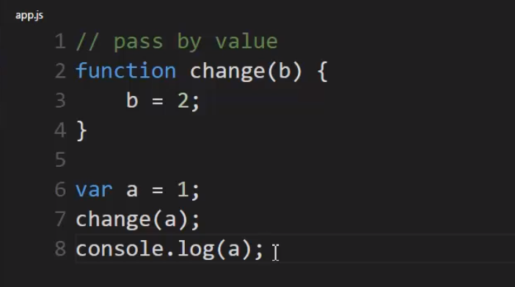



Why?

Because when change was called and this value A

was passed to B, A is a Primitive value, it's a number.

And so, B became a copy of this value,

and when I changed B, it changed a different spot in memory

than the spot that A is pointing at.

So, what happened inside the change function

didn't impact A at all.

### By Reference -

when we pass an object to a function,

something very different happens.

A might point to an object,

remember an object is just a collection of name value pairs.

And it also will be sitting in a particular spot in memory.

But when we call a function,

we pass it to a function,

that variable, that perimeter inside the function,

points to the same spot in memory

that our original variable does.

This is called pass by reference,

meaning no new copy of the object is made

but it's actually two variables pointing now

to the same location in memory.

And so when you change one, you change the other.

Because it's actually the same value.

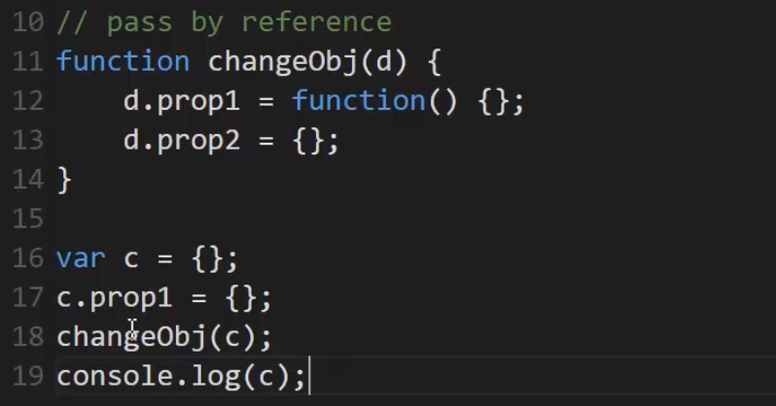

Output - 

So remember this,

when I pass in an object, I can add properties

and change properties on that object,

and that will be reflected outside of the function

because of pass by reference.

## 22. Immediately Invoked Function expression(IIFE)

### Scope

Scope, essentially at it's most basic,

scope means where in code you have access

to a particular variable or function.

So have a variable, perhaps it's

a number, a string or an object

or have a function, where else in my code

can I access it?

### IIFE

we've seen that I can do a function expression

in which can be anonymous,

that is I have no name.

And it will create a function on the fly.

However, just sitting here by itself,

JavaScript engine will view it as

a regular function statement, that is,

a normal kind of basic kind of,

first function that you might learn to try and create.

However, we don't want a basic function

because that won't give us the extra functionality

that we need.

What we need is a function that's created

and available to us in an immediate sort of sense.

As if I was, perhaps creating a string.

See I could say a string and then do a dot

and then have access to the things that

I could do with a string.

Or I could do a number and a dot

and have access to things I can do with a number.

So I need a function and then immediately be able to run the function.I can do that by telling the engine that this is meant to be an expression

and there's a few ways to do that.

The most common way is to simply wrap

this in parenthesis.

That means it's an expression now,

not just a function statement.

I'm telling the engine,

the engine will interpret this as,

all right now I have a function object I'm holding onto

and I can keep going.

I can keep doing things with it,

like invoke it.

So I can put parenthesis right here.

And I'll put a semi-colon.

So I create a function and then immediately invoke it.

So this is a function expression

and I've immediately invoked it.

So it's an immediately invoked function expression.

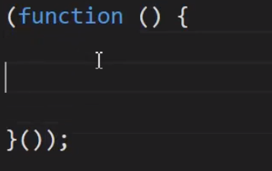

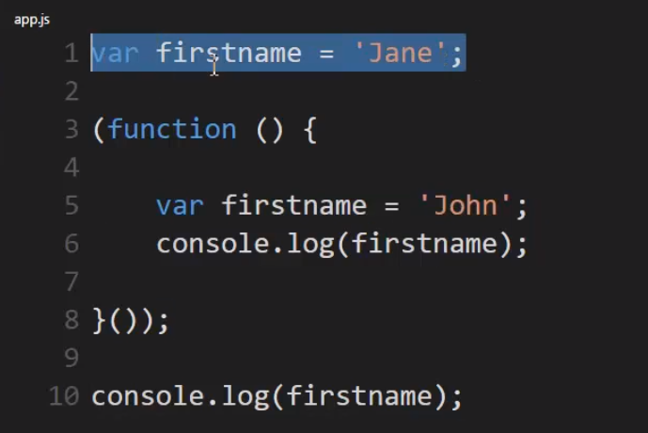

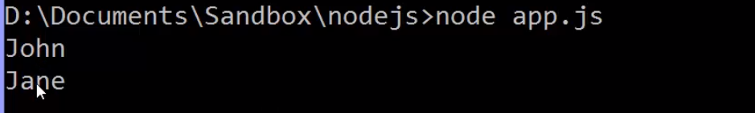

In other words, the creation of this firstname variable

within the immediately invoked function expression

impacted in no way, the firstname variable

that I declared before it.

Why?

Because of scope in JavaScript.

Whatever you create, whatever variables

you create, functions you create,

within a function in JavaScript,

is protected within that function.

It's only accessible within that function.

It's scoped to that function.

This is intentional.

And as a result, it's the way

that JavaScript developers for a long time,

have been kind of faking what a module should be.

In other words,

we can wrap our code in

an immediately invoked function expression

and make sure that it doesn't unintentionally affect

anything outside of it.

This console.log gets the firstname that was intended, not the one that I created inside of here.

So this was in a separate JavaScript file

and I loaded this JavaScript file,

this immediately invoked function expression.

It wouldn't surprise me

and change the value of firstname.

This variable here is protected and completely separate from the variables that are declared, that are created inside any particular function.

**Another example -** 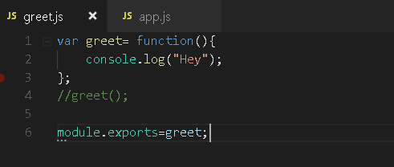

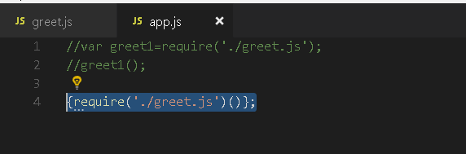



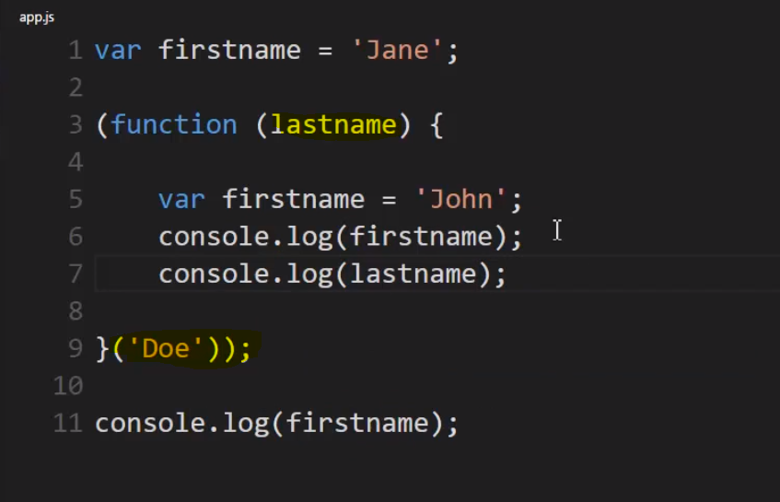 Oh and one other thing.

I can actually use a function like I normally would. So, let's say I want a lastname, to be able to pass to this function. Well, I can pass it to the function where I invoke it right here with these parenthesis.

## 32. Object properties, first class functions and arrays

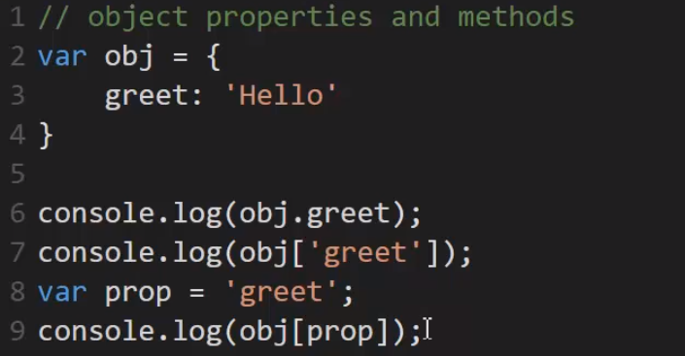

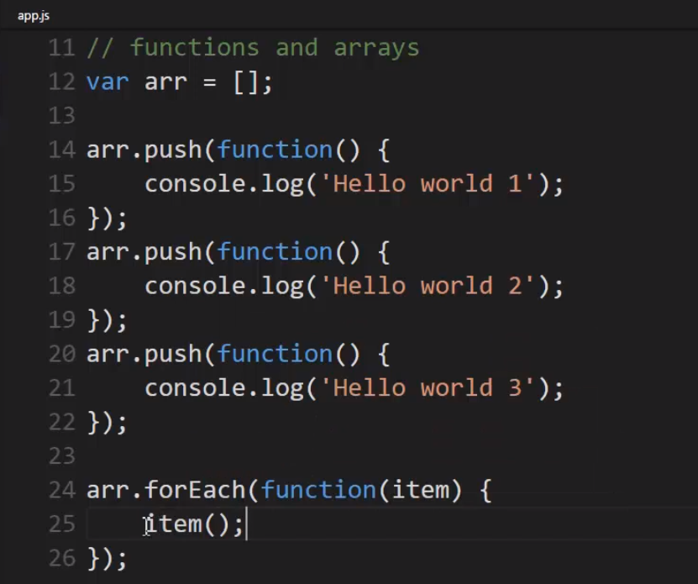

An array is just a collection of things in JavaScript, and it could be a collection of anything. And I can use dot push to add a new item to that collection, and it could be

a number, it could be a string, and because functions are first class in JavaScript, I can use them like I do any other variable, it could be an object and can be just a function here. And I use a function expression to create the function on the fly.

So I now have three elements, three items in my array, and they happen to all be functions, so three functions sitting in an array ,Not the value that comes back from the function,

I haven't invoked the function, just the function itself is sitting in the array.

Now because it's a function, I can invoke it. I can invoke any of these functions,

but I need to loop through the array to do that or grab a specific element in the array.

There is a number of ways I could loop over the array, but we'll use one that's built in. Every array gets a forEach property, and all that means is I give it a function to run,

I pass it to this forEach function. I pass it a function, and then inside the forEach it will call this function

## 35.Object.create and Prototype

prototypal inheritance in JavaScript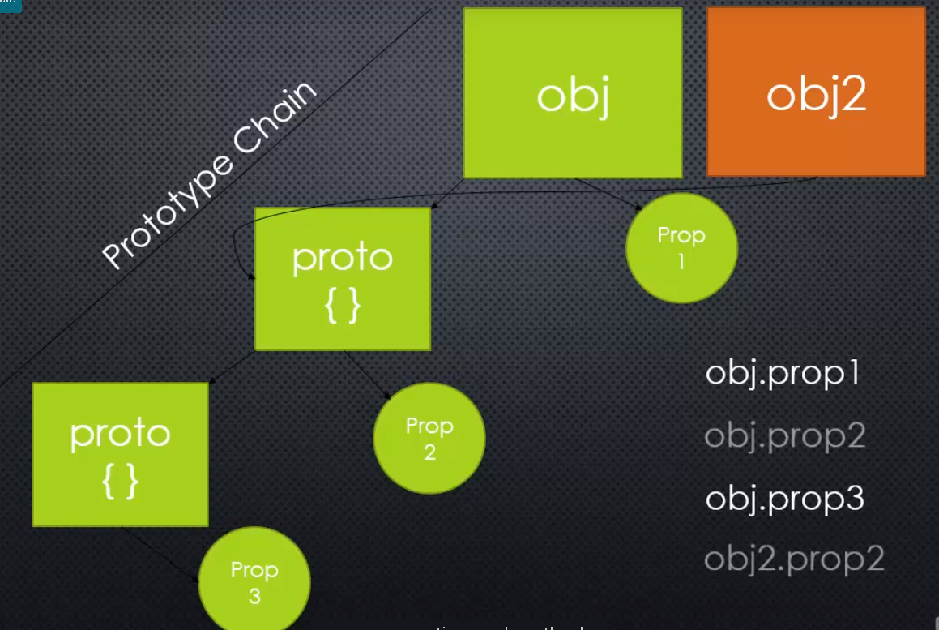

that's how JavaScript accomplishes the idea of inheritance.

There are a number of ways to set up the prototype chain, to set up objects and say

what they inherit from. We've already seen function constructors. There's classes in the new version of JavaScript ES6, the class idea has a keyword called extends that sets up the prototype chain.

And there's one more, very simple approach that JavaScrit has, which I really like.

instead of using a function constructor to construct the object, I'm just using an object literal, I'm just building the object itself that will be my prototype.

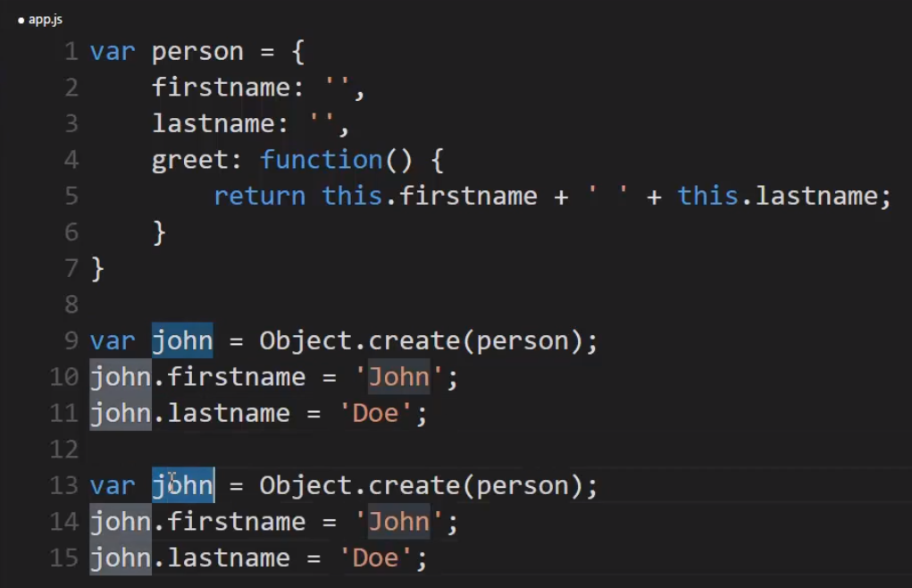 

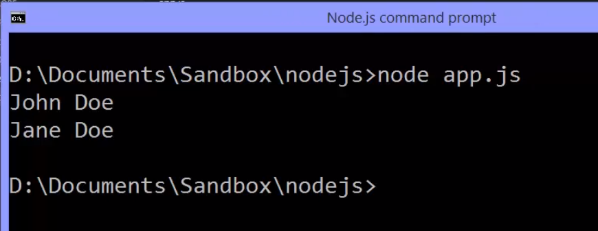

I can use Object, with a capitol O, dot create. And then tell it what to create that object from. When I'm done, I'll have an empty object, John, whose prototype is this person object, meaning the John object will have access to first name, last name, greet, all the methods and properties. And I can over-write them or block the ones on the prototype by simply adding properties and methods of the same name directly to the object.

**So when the JavaScript engine looks for first name, it will find it on the John object and not bother going down the chain to find it on person. But if I say greet, it won't find it on John, it'll go down to the person object and find it there.**

So both of these objects have access down the prototype chain.

Object.create is a very simple, fast and clean way to set up inheritance, that is the prototype chain, that is objects being able to use properties and methods of other objects.

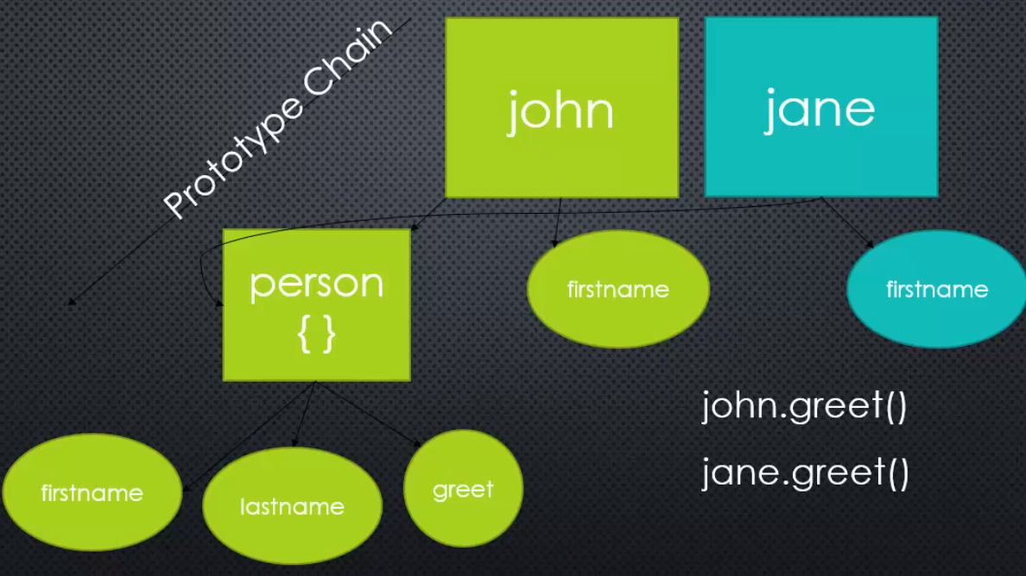

So we had a person object, which had some properties on it, first name, last name, a greet method.

And then when we used Object.create, we said Object.create and passed to it person

and that set up a new object, an empty one.

Object.create is a very simple, clean and clear way to set up a sequence of objects,

objects that inherit from one another, a prototype chain.

# Template Literal

Template Literal is a way to concatenate strings in Javascript, that is the new version ES6. And it's easier to work with than a bunch of strings concatenated with plus operator

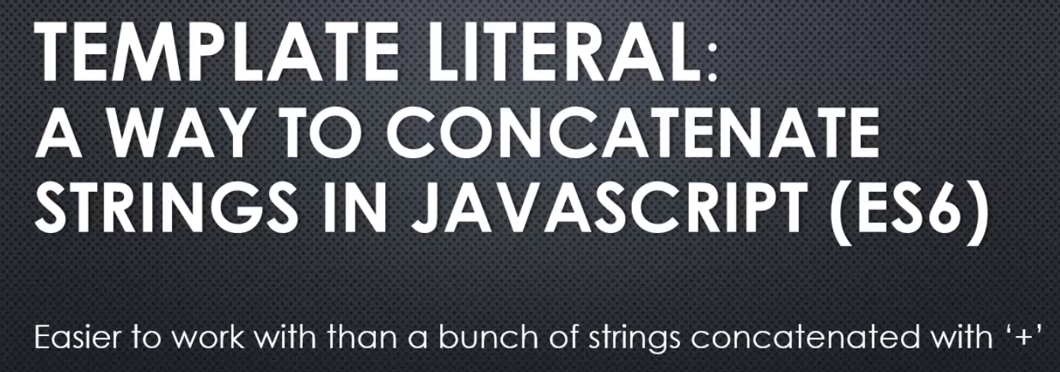

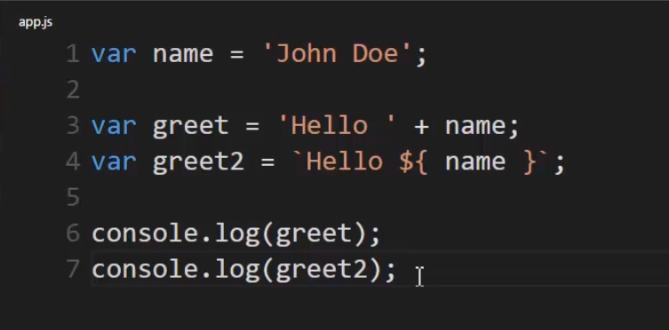

**Instead of using a single quote, I'll use what's called a back tick**, or a grave accent, that's found usually in the upper left corner of your keyboard if you're using the US or UK qwerty keyboard layout.

So, the back tick, it's not a regular quote, but rather a back tick or grave-accent mark, and **that tells the Javascript engine that this is going to be a Template Literal**. I can put a regular string it, but wherever I want something that's evaluated, a variable, an expression, whatever the case, I put dollar sign and then curly braces. Curly braces like I was doing a block like an if, or a for, or an object literal. And inside those curly braces I can put Javascript code and then terminate the Template Literal with a back tick or a grave accent.

So this is a Template Literal. It let me insert Javascript code without having to stop the string and use pluses to concatenate and everything else. This is a lot faster and easier and less prone to mistakes.

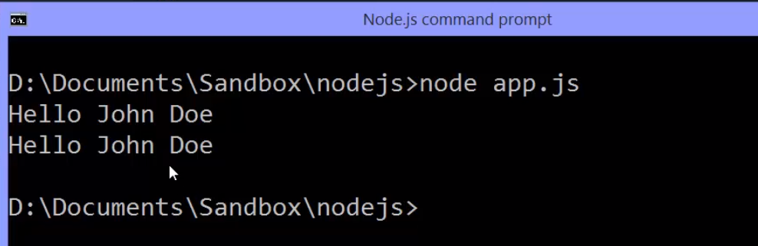

Now again, i can't do this in every browser, because it may not be supported. If I want to do this in the browser I have to use something like Babel in order to conver this to this.

**So Babel would take this code I've written and convert it to this before we actually give it to the browser. But in the case of Node I can just use this as is, give it straight to the V8 engine because it's the latest version of V8 engine, this is supported.**

# 38 Javasccript Aside : .bind() .call() and .apply() for invoking function

Functions are objects in JavaScript. And as objects, functions have methods, including the powerful Apply, Call, and Bind methods.

As functions are also Objects in JavaScript, these 3 methods are used to control the invocation of the function. call() and apply() were introduced in ECMAScript 3 while bind() was added as part of ECMAScript 5.

These JavaScript methods allow you to change the value of ‘**this**’ for a given function.

//

## **Basic rules worth remembering:**

“this” always refers to an object.

“this” refers to an object which calls the function it contains.

In the global context “this” refers to either window object or is undefined if the ‘strict mode’ is used.

//

Note : You can use call()/apply() to invoke the function immediately. bind() returns a bound function that, when executed later, will have the correct context (**"this"**) for calling the original function. So bind() can be used when the function needs to be called later in certain events when it's useful.

//

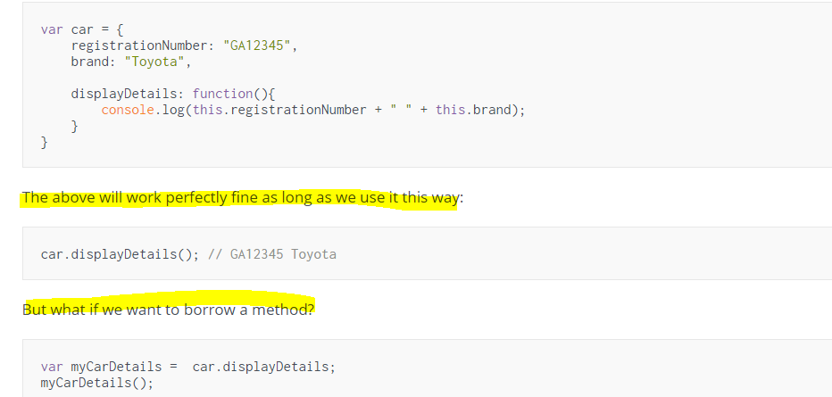

Well, this won’t work as the “this” will be now assigned to the global context which doesn’t have neither the registrationNumber nor the brand property.

## The .bind() Method or *Function.prototype.bind()*

For such cases we can use the ECMAScript 5 bind() method of the Function.prototype property. This means bind() can be used by every single function. The [Bind](https://developer.mozilla.org/en-US/docs/Web/JavaScript/Reference/Global_Objects/Function/bind) method returns a new function, allowing you to pass in a this array and any number of arguments. Use it when you want that function to later be called with a certain context like events.

var myCarDetails = car.displayDetails.bind(car);

myCarDetails(); // GA12345 Toyota

The bind() method creates a new function where “this” refers to the parameter in the parenthesis in the above case “car”. This way the bind() method enables calling a function with a specified “this” value.

What if we would like to pass a parameter to the displayDetails function? We can use the bind method again. The following argument of the bind() method will provide an argument to the function bind() is called on.

Let me rewrite the car object:

var car = {

registrationNumber: "GA12345",

brand: "Toyota",

displayDetails: function(ownerName){

console.log(ownerName + ", this is your car: " + this.registrationNumber + " " + this.brand);

}

}

Example of passing arguments with bind():

var myCarDetails = car.displayDetails.bind(car, "Vivian"); // Vivian, this is your car: GA12345 Toyota

//

This might seem relatively trivial, but often the this value in methods and functions **must** be set explicitly when you need a specific object bound to the function’s thisvalue.

The need for bind usually occurs when we use the this keyword in a method and we call that method from a receiver object; in such cases, sometimes this is not bound to the object that we expect it to be bound to, resulting in errors in our applications.

//

## The .call() method or Function.prototype.call() And .apply() method or Function.prototype.apply()

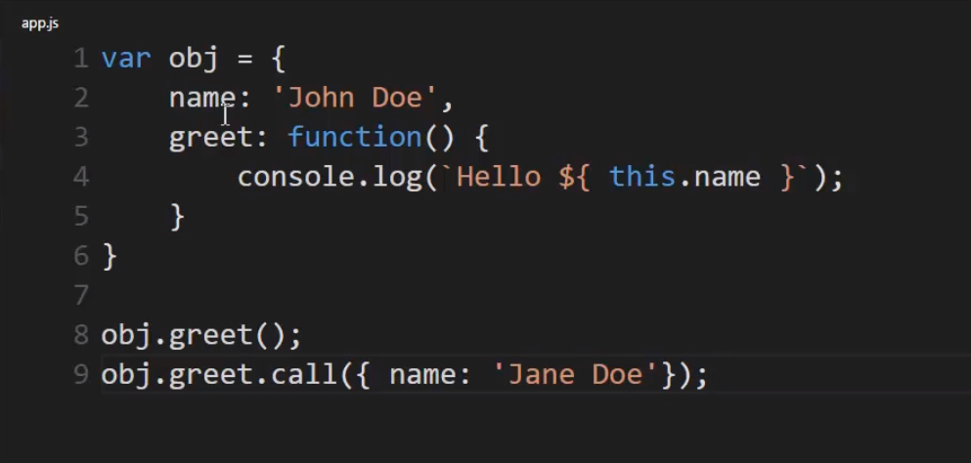

 I'm going to use dot call. I can take any function, because functions are objects in JavaScript. They're first class, so they have their own methods and properties. I can say dot call. This will invoke the function. Just like the parenthesis do.

But the difference is,

I can pass a variable to it. And whatever I pass to call is what the this keyword will point to. So, I'll overwrite what the this keyword points to.

And that allows for some pretty powerful patterns,

like I could just create an object here. I'll use an object literal. And say Jane Doe is the name. So, I'm passing an object to this function via dot call, and what that really means is

this object will become the this keyword. So, this function will run as normal, but wherever I see the this keyword instead of pointing to the parent object, it will instead point to the object I passed in via dot call.

**So, I'm essentially borrowing this function, and giving it my own object to serve as the this keyword.**



**.apply works exacly the same as .call**

The only difference between dot call and dot apply is if I had some parameters here, for the function, you do a comma for call and pass the parameters and other parameters if there are any.

But for apply, you simply pass an array of parameters. And that's the only difference as far as how you pass them. Either a single array, or pass them as a comma separated list like you normally would with a function.

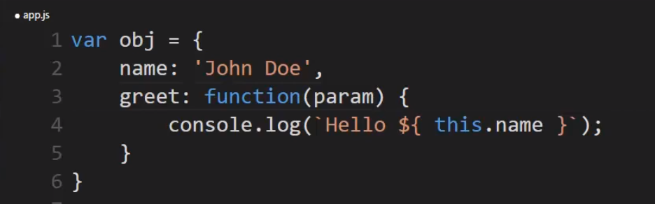





**call and apply let me change what this keyword points to. And that turns out to be a very powerful option for essentially borrowing methods and giving it the object I want them to work on.**

# ES6 Classes

**It's basically a new way to build objects**. But while it's a new way from a syntax standpoint, from the code that you write, it doesn't really change anything under the hood, and for that reason, it's called syntactic sugar.

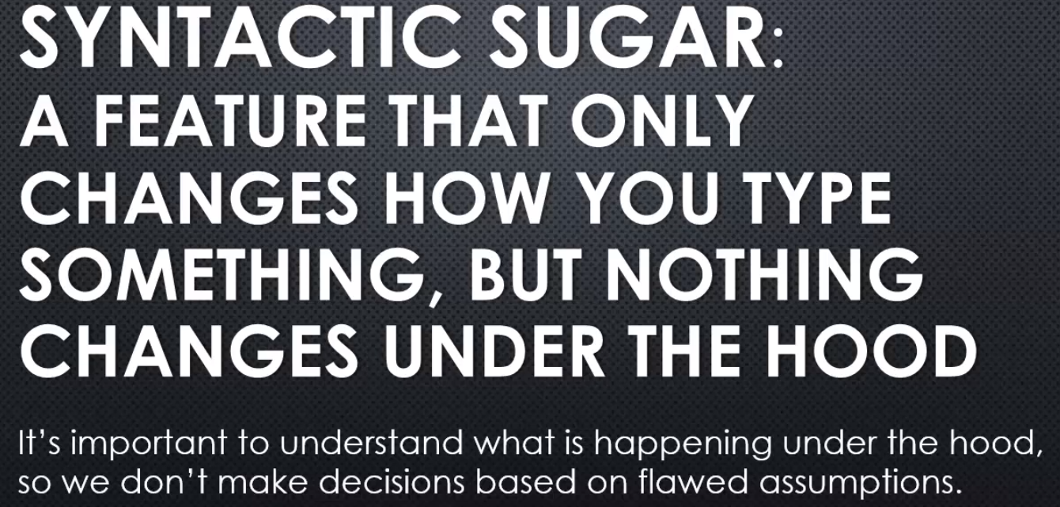

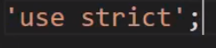

adding that line to the top of the JavaScript file or function means that the JavaScript engine will be pickier about things that it lets you or doesn't let you do.

It helps you not make silly mistakes and it's something you should do in real production code.

the engine will choose to only allow those new features to be used if we've opted into using the stricter variety of JavaScript, that is, to be pickier about certain things we can do.

So for example,

I can't just use a variable without declaring it.

If I didn't have use strict, this would run and make this a global variable, but if I have use strict, this will be an error unless I put the var keyword.

Lets create a class

**so what happens is anything you've added to the object inside constructor works like a function constructor in that it adds it to each object created.**

**And any other methods you put inside the class are automatically put on the prototype.** **so that they're available in one spot and available down the chain to all objects created from this class.**

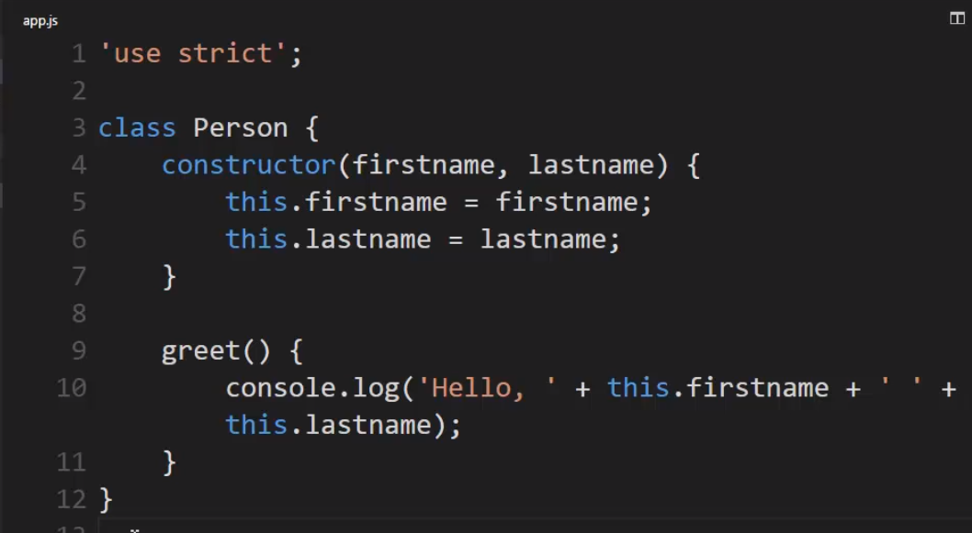

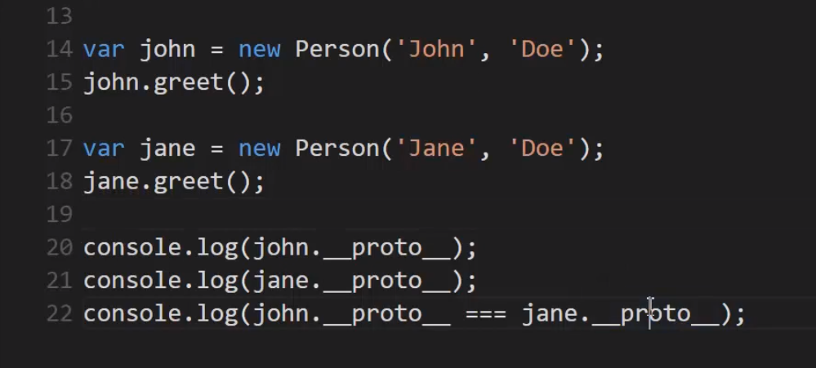

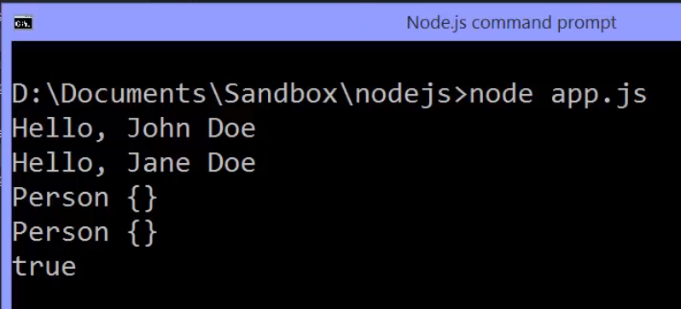

if you're coming from C++, or programming in Java or C#,But in those other languages, classes are very, very different things.

**Inside JavaScript, class is just really syntactic sugar. It's essentially a function, and the constructor keyword and those properties and methods that you're putting on the prototype, that's all happening behind the scenes, and so you're separated a little bit from what's really going on. You don't even see the concept of prototype in the syntax.**

# Javascript is Synchronous

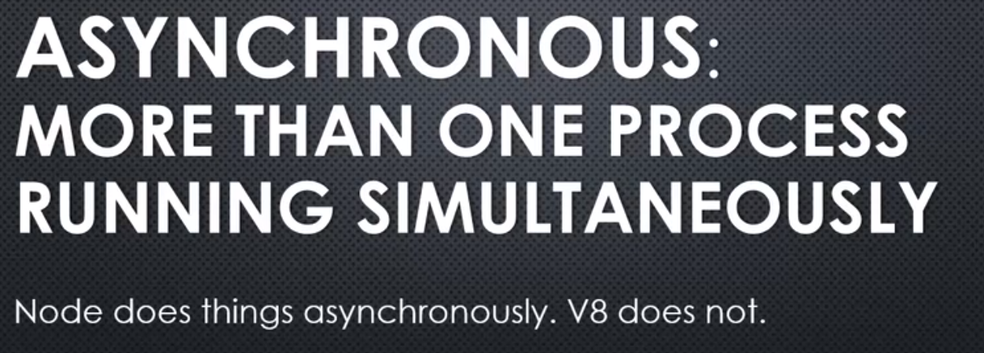

**We've seen in the C++ core, V8 engine is running, and there is a variety of things happening within Node itself. It's doing more than one thing at a time.**

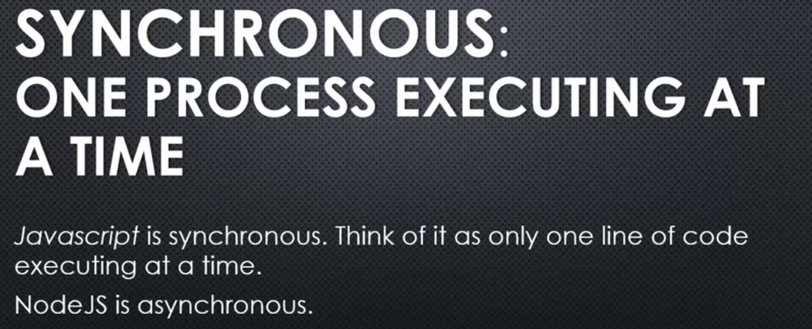

This is a common misconception when it comes to Javascript Node.

You may hear the term asynchronous Javascript, but that's really a misleading term.

**Javascript is designed to be synchronous. There's only one thing running at any point in time. Basically, one line of code running at any point in time.**

**But Node.js is asynchronous. V8 is inside of it, embedded. And so, while V8 is running Javascript code, converting it to machine language, executing it; Node can do other things as well. Not just let things run inside the V8 engine.**

**So, whenever we talk about asynchronous Javascript, we're not really talking about the Javascript engine itself, but rather, whatever the Javascript engine is sitting inside of; like the browser, or Node.**

**And, things happening inside the engine running simultaneously alongside the engine as well, and how the engine responds to things that happen outside of it. Things that are happening at the same time.**

# Callbacks

**a function passed to some other function which we assume will be invoked at some point. So the function that we're calling calls back invoking the function we give it.**

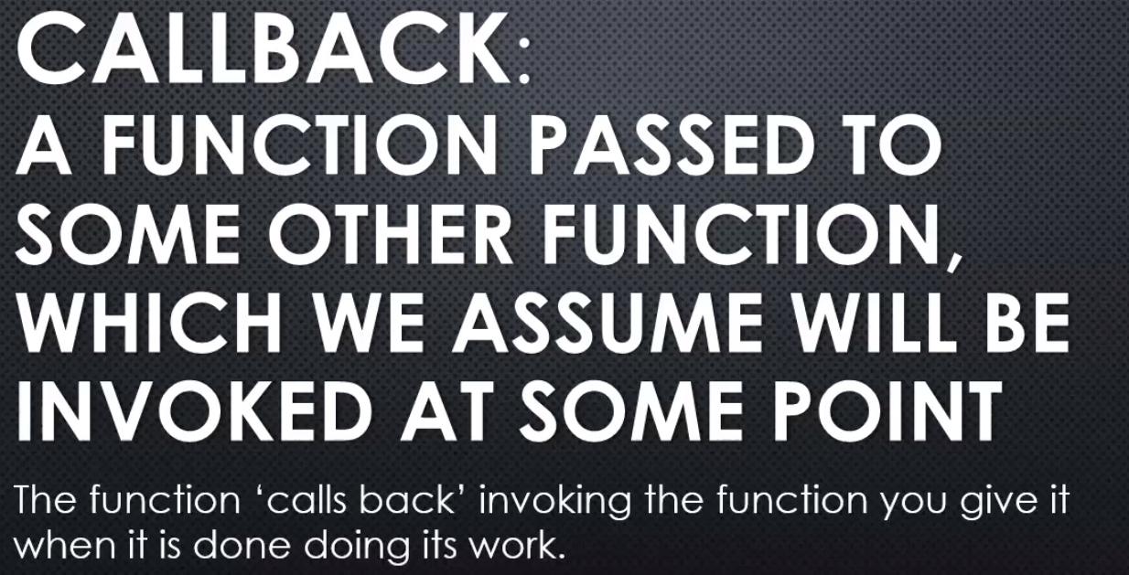

Callback is some code you give to other code to be run at some point while that other code is running.

let's take a quick look at how we do that in JavaScript.

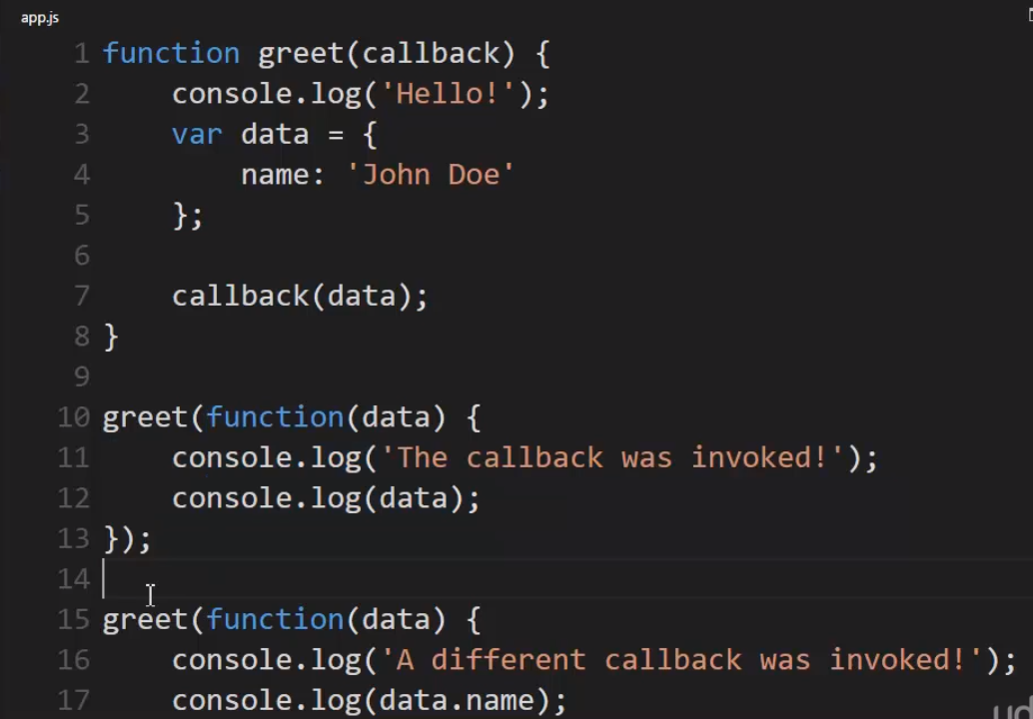

I could name this whatever I wanted. I'll name it callback to be clear. And the callback will be a function itself. Remember functions in JavaScript are first class so I can pass them around, set them to variables, et cetera.

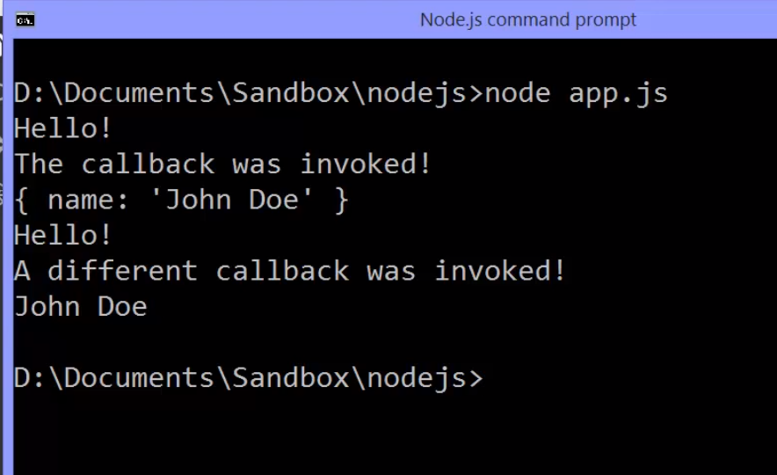

**So there's lots of things you can do with a callback pattern.**

**You could, for example, have a function that goes out and gets data from the database, but then you might call that function different ways at different times. And want to do different things with that data. So you could just give it a callback, have it give you the data and then do what you want to with the data.**

The function I invoke will invoke later the function that I give it.

# ES6 Typed Arrays

We said that buffers exist in Node because JavaScript didn't have good ways to deal with binary data.

Well, that's changing a bit in the next version of JavaScript, in ES6, the latest version.

So let's take a moment to talk **about ES6, typed arrays.**

**the latest version of the V8 imbedded engine, has access to something that can deal with binary data.**

I'll say var buffer equals and then I'll create a new ArrayBuffer. Then, I'll say a size, it wants a size in bytes. A byte is eight bits.

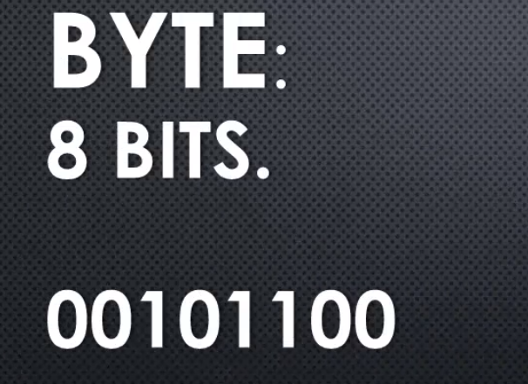

Remember, a bit is a binary digit, zeroes and ones. In other words, a byte is eight zeroes or ones. I'll say eight bytes. **So this is storing raw binary data.**

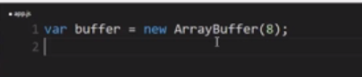

This is storing eight bytes, that is eight times eight, or 64 bits of data.

**This is not coming from Node, this is coming from the V8 JavaScript engine, this is a new feature in JavaScript. This has nothing to do with Node, it's just there because V8 is embedded in Node.**

How do I deal with my binary data?

Well, I can create what's called a **view**.

**The view is actually a typed array**, meaning that it's an array and I can deal with it as an array**. I'll create an Int32Array, and then give it the buffer to work with.**

What it really is, though, is it's simply a way for me to deal with the binary data in the buffer.

**If I changed the array, I'm actually changing the buffer. When I read from the array, I'm actually reading from the buffer.**

and it will convert that binary data into whatever structure I say is the structure that I should be looking at.

So in this case, **I said Int32. That means a number, an integer, stored with 32 bits, 32 zeroes and ones.**

So how many numbers can I store in my buffer?

Well, this is eight bytes. That is, a byte is eight bits, so this is eight times eight, 64 bits.

And this is 32 bits for one number. We'll use 32 zeroes and ones to store one number, which means we can store pretty big numbers,

but we can only store two numbers in this view as we have assigned 32 bits for one number.

So, I can use it as an array and I can use regular base 10 numbers. Then, I can console.log the view, and I can see the data in regular base 10, even though, see that?

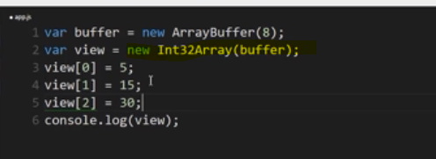

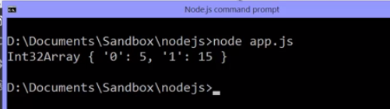

**the zero position holds a five, the one position holds a 15, even though what's really happening is this is being converted into 32 bits for a five, and 32 bits for a 15. Because the array buffer only holds two bytes, then, all I can do is store that.**

if I tried to put a third number in there, it doesn't error, but it's not there, the buffer doesn't have the storage for it.

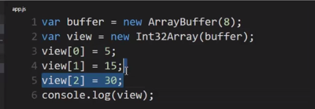

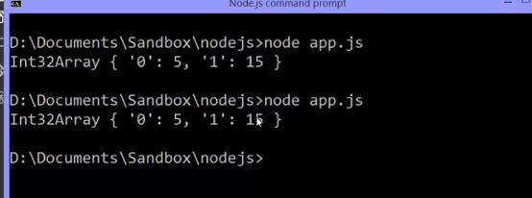

**So this view is just letting me work with binary data in an easier way. Letting me put in normal base 10 numbers.**

We're not going to use this through the rest of the course because right now **Node doesn't use this itself, it uses the buffer that's internal to Node and the C++ side.**

We should be aware of it because we don't want to walk away thinking, oh the buffer is there because JavaScript can't deal with binary data. It used to not be able to deal with binary data, this is new for ES6. It's availability depends, again, on what version of Node you're running.

However, it's good to know about so that we have clear in our minds that the **new version, ES6, the new version of JavaScript, does have ways of dealing with raw zeroes and ones, with raw binary data.**